**Academic Year 2023-24**



**MAHARASHTRA STATE BOARD OF TECHNICAL EDUCATION, (MUMBAI)**

**A**

**Project Report**

**on**

**“ A holistic approach to campus recruitment and student profile analysis for placement. ”**

***Submitted by:***

|  |  |  |
| --- | --- | --- |
| **Sr. No.** | **Name of Student** | **Exam Seat No.** |
| **1)** | **Dhakane Aditya Arun** | **: 376751** |
| **2)** | **Bangar Kalyani Hemant** | **: 376744** |
| **3)** | **Gaidhani Shraddha Punjaram** | **: 376755** |
| **4)** | **Salunke Ashwini Ashok** | **: 376781** |

***Under the Guidance of:***

**Name of Guide:Mr. S.H.Sangale**

**Designation : Lecturer in Computer Technology**



**Department of Computer Technology**

**K. K. WAGH POLYTECHNIC, NASHIK**

**Academic Year 2023-24**

KarmaveerKakasahebWagh Education Society’s

**K. K. WAGH POLYTECHNIC**

HirabaiHaridasVidyanagari, Amrutdham, Panchavati, Nashik-422003, Maharastra

|  |  |  |
| --- | --- | --- |
|  |  |  |

This is certify that Ms. **Bangar Kalyani Hemant** From K.K.Wagh Polytechnic Nashik College having Enrollment No. **2100780078** has completed Report on the Semester Vth Project Report having title **A holistic approach to campus recruitment and student profile analysis for placement.** in a group consisting of 4 persons under the guidance of the Faculty Guide.

*(Name& Sign of InternalGuide)* Prof.G. B. Katkade

Internal Guide HOD- Computer Technology

( Sign of Mentor from the Institute) Prof. P. T. Kadave

Name: Mr. S. H. Sangale Principal

Contact: 7709187681

**Academic Year 2023-24**

KarmaveerKakasahebWagh Education Society’s

**K. K. WAGH POLYTECHNIC**

HirabaiHaridasVidyanagari, Amrutdham, Panchavati, Nashik-422003, Maharastra

|  |  |  |
| --- | --- | --- |
|  |  |  |

This is certify that Mr. **Dhakane Aditya Arun** From K.K.Wagh Polytechnic Nashik College having Enrollment No. **2100780086**  has completed Report on the Semester Vth Project Report having title **A holistic approach to campus recruitment and student profile analysis for placement.** in a group consisting of 4 persons under the guidance of the Faculty Guide.

*(Name& Sign of InternalGuide)* Prof.G. B. Katkade

Internal Guide HOD- Computer Technology

( Sign of Mentor from the Institute) Prof. P. T. Kadave

Name: Mr. S. H. Sangale  Principal

Contact: 7709187681

**Academic Year 2023-24**

KarmaveerKakasahebWagh Education Society’s

**K. K. WAGH POLYTECHNIC**

HirabaiHaridasVidyanagari, Amrutdham, Panchavati, Nashik-422003, Maharastra

|  |  |  |
| --- | --- | --- |
|  |  |  |

This is certify that Ms. **Gaidhani Shraddha Punjaram** From K.K.Wagh Polytechnic Nashik College having Enrollment No. **2100780090** has completed Report on the Semester Vth Project Report having title **A holistic approach to campus recruitment and student profile analysis for placement.** in a group consisting of 4 persons under the guidance of the Faculty Guide.

*(Name& Sign of InternalGuide)* Prof.G. B. Katkade

Internal Guide HOD- Computer Technology

( Sign of Mentor from the Institute) Prof. P. T. Kadave

Name: Mr. S. H. Sangale  Principal

Contact: 7709187681

**Academic Year 2023-24**

KarmaveerKakasahebWagh Education Society’s

**K. K. WAGH POLYTECHNIC**

HirabaiHaridasVidyanagari, Amrutdham, Panchavati, Nashik-422003, Maharastra

|  |  |  |
| --- | --- | --- |
|  |  |  |

This is certify that Ms. **Salunke Ashwini Ashok** From K.K.Wagh Polytechnic Nashik College having Enrollment No. **2100780128** has completed Report on the Semester Vth Project Report having title **A holistic approach to campus recruitment and student profile analysis for placement.** in a group consisting of 4 persons under the guidance of the Faculty Guide.

*(Name& Sign of InternalGuide)* Prof.G. B. Katkade

Internal Guide HOD- Computer Technology

( Sign of Mentor from the Institute) Prof. P. T. Kadave

Name: Mr. S. H. Sangale  Principal

Contact: 7709187681

**Sponsor’s Certificate**

**IIC Participation Certificate/ Appreciation Certificate(s)**

#### **acknowledgement**

With deep sense of gratitude we would like to thanks all the people who have lit our path with their kind guidance. We are very grateful to these intellectuals who did their best to help during our project work.

It is our proud privilege to express deep sense of gratitude to,Prof. P. T. Kadave, Principal, K.K.Wagh Polytechnic, Nashik for his comments and kind permission to complete this project. We remain indebted to Prof. G.B. Katkade, Head of Computer Technology Department for his timely suggestion and valuable guidance.

The special gratitude goes our external guide **Mr.P.M.Mohan**, TPO Officer at our **Institute Sponsor**: K.K.Wagh Polytechnic Nashik and Internal Guide **Mr. S.H.Sangale ,** staff members, technical staff members, of Computer Technology Department for his expensive, excellent and precious guidance in completion of this work. We thanks to all the class colleagues for their appreciable help for our working project.

With various industry owners or lab technicians to help, it has been our endeavor to through out our work to cover the entire project work.

We also thankful to our parents who providing their wishful support for our project completion successfully.Lastly we thanks to our all friends and the people who are directly or indirectly related to our project work.

Names of Students Class

1) Dhakane Aditya Arun TYCM-Lin

2) Bangar Kalyani Hemant TYCM-Lin

3)Gaidhani Shraddha Punjaram TYCM-Lin

4) Salunke Ashwini Ashok TYCM-Lin

**Abstract**

The ICRPT (Integrated campus recruitment, placement and training analysis) is a comprehensive software solution designed to streamline the process of connecting students with job opportunities and facilitating effective communication between teachers (TPO), students, and HR professionals. The system is organized into three main entities: Teachers (TPO), Students, and HR Personnel, each with their specific roles and functionalities. The ICRPT designed to improve the efficiency of job placement processes for educational institutions and organizations alike. It promotes transparency, simplifies data management, and facilitates effective communication among teachers, students, and HR professionals, ultimately enhancing the employability of students and the recruitment process for companies.

The ICRPT is a sophisticated and user-friendly software solution aimed at seamlessly connecting students with potential job opportunities, enhancing their skills, and simplifying the recruitment process for organizations. This system consists of three primary entities: Teachers (also known as Training and placement Officer), Students, and HR Personnel, each playing pivotal roles within the platform. The ICRPT is a powerful tool for educational institutions and organizations, fostering transparency, efficiency, and effective communication. It empowers students to enhance their skills, enables HR professionals to streamline the recruitment process, and supports teachers (TPO) in guiding students towards successful career opportunities. With its comprehensive features, ICRPT bridges the gap between education and industry, ultimately contributing to the growth and development of both students and organizations.

ICRPT addresses the critical need to bridge the gap between education and industry by providing a centralized platform for students and HR professionals. It enhances employability and simplifies recruitment. officer can manage student and company profiles, act as HR professionals, and release assessment scores. Students can maintain profiles, participate in quizzes, take aptitude tests, and access recorded assessments. HR personnel can post vacancies, create quizzes, review recorded assessments, evaluate candidates, extend job offers, and release scores.

ICRPT leverages modern web development technologies and databases to create an intuitive user interface. It incorporates features such as profile management, quiz participation, aptitude testing, video/audio recording, vacancy posting, quiz creation, video review, candidate evaluation, and offer letter generation.

The project anticipates improved student employability, efficient recruitment processes, and transparent assessments. Students can monitor their performance, and HR professionals gain valuable insights into candidates' skills and suitability.

**Keywords**: *Data-Driven, Recruitment Strategy, Career Readiness, Data Visualization, Transparent Assessments*

**Table of Contents**

|  |  |  |
| --- | --- | --- |
| Sr. No. | Name of Topic | Page no. |
| I | 1. Title Page 2. Certificate 3. Sponsor’s Certificate 4. Acknowledgement 5. Abstract 6. Table of Contents 7. Index of Figures & Index of Tables | i |
| 1. | Introduction | 1 |
| 2. | Literature Survey | 3 |
| 3. | Project Requirement Analysis & Feasibility | 5 |
| 4. | Project design and Analysis | 11 |
| 5 | Project Scope | 20 |
| 6. | Applications | 21 |
| 7. | Advantages and Disadvantages | 23 |
| 8. | Conclusion | 24 |
| 9. | References | 25 |

**Index of Figures**

|  |  |  |
| --- | --- | --- |
| Fig. No. | Name of Figure | Page no. |
| 4.1 | System Architecture. | 11 |
| 4.2 | ER Diagram | 12 |
| 4.3.1 | Data Flow Diagram: level 0 | 13 |
| 4.3.2 | Data Flow Diagram: level 1 | 14 |
| 4.3.3 | Data Flow Diagram: level 2 | 15 |
| 4.4.1 | Use Case Diagram | 16 |
| 4.4.2 | Class Diagram | 17 |
| 4.4.3 | Activity Diagram | 17 |
| 4.4.4 | Deployment Diagram | 18 |

**Index of Tables**

|  |  |  |
| --- | --- | --- |
| Tab .No. | Title of Table | Page no. |
| 3.1 | Functional Requirements. | 5 |
| 3.3 | System Implementation Plan | 8 |

**Chapter – 1 : INTRODUCTION**

**1.1 Problem Defination**

The task is to design and develop a Training and Placement Application that streamlines the process of connecting job seekers (students or candidates) with potential employers (companies) while providing comprehensive support for skill development, job search, and placement activities.

**1.2 Overview**

In a world where the job market is constantly evolving at a rapid pace, the alignment between education and industry stands as a pivotal concern. Educational institutions today are entrusted with the responsibility of preparing students not only with the foundational knowledge but also with the practical skills necessary to thrive in their chosen careers. Simultaneously, organizations are on the hunt for the most qualified and competent candidates who can seamlessly integrate into their dynamic and everevolving workforce.

However, despite the shared goal of preparing students for the workforce, the transition from academia to the professional world is often marked by numerous challenges for both students and employers. Graduates may find it challenging to translate their educational experiences into practical job skills, and employers may struggle to identify the most suitable candidates who align with their evolving needs and industry demands. To address these intricate challenges and to foster a harmonious connection between students and potential employers, we are proud to introduce the "Integrated Campus Recruitment, Placement, and Training Analysis" (ICRPT) system. Developed with the specific needs and aspirations of our college students in mind, ICRPT represents a cuttingedge solution designed to bridge the gap between the academic realm and the professional landscape. With ICRPT, we embark on a journey to revolutionize the way our students prepare for their future careers and how employers identify the bestfit talent.

This innovative system leverages the power of data-driven analysis, comprehensive student profiling, and a holistic approach to campus recruitment, placement, and training. It not only helps students gain a clearer understanding of their strengths, weaknesses, and career potential but also empowers our institution to tailor educational experiences that align with the demands of the job market. On the employer's side, ICRPT streamlines the recruitment process by offering insights into the most promising talent pool among our students, thereby saving valuable time and resources. With ICRPT, we embark on a transformative journey that puts our students at the forefront of industry readiness and ensures that the knowledge and skills they acquire during their time at our college are directly applicable in their future careers. We invite you to explore this dynamic system and join us in shaping a brighter and more prosperous future for our students and the organizations that seek their talents. This innovative system represents a pivotal shift in the way we prepare and connect

our students to the professional world. It's a strategic move towards nurturing well-rounded, job-ready graduates who are not just academically accomplished but also equipped with the skills and insights needed to thrive in today's competitive job market. Through this system, we reaffirm our commitment to empowering students and ensuring the long-term success of our educational institution.

**1.3 Motivation**: Aim of the Training and Placement Application is to bridge the gap between job seekers and employers, making the job search and placement process more efficient, effective, and user-friendly. It strives to empower individuals with the tools and opportunities to advance their careers while helping companies find the right talent for their needs.

**Chapter – 2 : LITERATURE SURVEY**

Research paper 1: Online Training and placement system.

Authors: Gunjan Jewani, Swati Sahare, Trupti Kamble, Ritu Kathalkar, Ashwini Unhale.

Description: The analysis in this paper main goal is to narrow or close the growing gap between students and the job market. The research looks at various job training programs offered on college campuses in an effort to shape our students into marketable human resources. The article also seeks to figure out how students should be actually encouraged to apply the lessons learned on college campuses to actual placement. Students can track status of their placement. Students can also update personal and academic information such as their email address, current semester, correspondence address and their grade across various semesters, a functional line of contact using modern technologies like email and SMS between the training and placement department and student it is helpful to have the most recent information on the companies visiting the campus.

Analyzing the students strength and weakness in order to develop a commitment that will be effective for the educational institutions training and placement activities based on the students query-specific report for various companies recruiting.

Research paper 2 : TNP portal using web development and machine learning.

Authors: Prasad Khalkar, Aditya Muthal, Sujit Khopade, Lokesh Ghule, Prof. Tushar A. Rane

Description: The placement of a student on campus has a big impact on a college. Companies visit colleges during campus placement to identified qualified candidates before they graduate. The most important factors for successful placement can be found by analyzing patterns and qualities in the massive volumes of student’s information that schools retain. The placement of engineering students beginning in their second year can be predicted, which can aid in the student’s correct development. Students may be given access to an interface that enables them to submit applications to several businesses with a single click. Obviating the need to update information that is already in the system. This can cut-down on the time and work needed to verify the information given by the pupils.

The other proposed subsystem uses predictive analytics with machine learning classification algorithms to determine the likelihood of placement in a given industry, such as fintech, startup, products and services. Additionally, it can identify key characteristics that influence a candidate’s chance of landing a job in that industry, benefiting both the college and the student.

Conclusion:

After a comprehensive analysis of IEEE papers and thorough research in the realm of Training and Placement application, We will introduce significant enhancements beyond the existing systems. User engagement can be limited, leading to incomplete profiles and reduced overall effectiveness. Additionally, handling sensitive personal and academic data raises concerns about data privacy and security breaches, which could have legal and reputational consequences.

Global Opportunities: Connect users with international job opportunities, promoting global career mobility.

Reduced Unemployment: By efficiently matching job seekers with relevant job openings and providing training opportunities, your application can contribute to reducing unemployment rates.

Increased Job Satisfaction: Job seekers are more likely to find positions that align with their skills and interests, leading to higher job satisfaction.

**Chapter – 3 : PROJECT REQUIRMENT ANALYSIS & FEASIBILITY**

**3.1 Functional Requirements**

|  |  |  |  |  |
| --- | --- | --- | --- | --- |
| Sr. no | Functions | Input | Process | Output |
| 1 | Candidate  Registration | Candidate detail (name, email, password) | Verify and store information | Confirmation message,  Candidate profile |
| 2 | Company  Registration | Company details ( name, email, password) | Verify and store company information | Confirmation message,  Company profile |
| 3 | Company job  posting | Job related details | Post job listing to the platform. | Post job list |
| 4 | Job matching | Candidate profile, job requirements | Match candidate to job opening based on skills and criteria. | List of matching job opening. |
| 5 | Skill assessment | Candidate skills  test | Evaluate candidate skills based on assessment | Skill assessment result |
| 6 | Submit job application and track  status | Job application details | Store application to the candidate and posting. Display the status of job application  (received, in progress, waiting, rejected) | Confirmation of application submission. Status of application |

**3.1.1 Communication Requirements**

1. **Message system:**

The system must provide a messaging platform that allows candidate to communicate with companies and vice versa. User should be able to send text message, attach files and include links.

1. **Notification system:**

Implements a notification system to alert users about new messages, meeting requests and application updates. Notifications should be delivered through the email or mobile notification.

1. **Privacy and security:**

Ensure that communication is secure and private, adhering to data protection regulation. Offer end-to-end encryption for sensitive conversation.

**3.1.2 Communication standards and Network server communications protocols:** HTTP, HTTPS

**3.2 Non-Functional Requirements**

1. **Performance:**

The system should response quickly to user action. System must handle a growing number of users, job listing and messages without significant degradation in performance. It should be able to handle peak loads, especially during job posting period, without crashing or slowing down.

1. **Security:**

Protect user data, including personal information, resumes and messages through encryption and data security. Assign roles and permissions to control who can access, modify or delete data.

1. **Usability:**

The user interface must be intuitive, accessible and user friendly.

1. **Compatibility:**

Ensure the application work consistently across various web broowsers(eg. Chrome, firefox, safari). The mobile web platform should function well on different operation systems(eg. iOS, Android).

**Hardware requirements:**

|  |  |  |
| --- | --- | --- |
| Sr. | Resource Name | Specification |
| 1. | Computer Processor | Intel core 5 or higher |
| 2. | Microphone | Mini Collar mic |
| 3. | Camera | Good Quality 3MP |
| 4. | Storage Space | 60GB or higher |
| 6. | Memory (RAM) | Minimum 4GB |
| 7. | Operating System | Windows 10+ |

**3.3 System Implementation Plan:**

Year planner chart is also called as time line chart. Time line chart is use for proper scheduling of project. A timeline chart can be developing for entire project. Alternately separate time line chart is developing for each function. A time line chart enables what task will be conducted at given point of time. The task set that is selected is collection of software engineering work task, milestone and deliverable that must be to complete a particular project. In timeline chart all project task are listed in left-hand column. The horizontal bar indicates duration of each task. When multiple bars occur at the same time, task concurrency is implied. The diamond indicates milestones. Time line chart help to determine how each task is initiated in addition it gives the understanding of priority and criticality of each task. When force with serve deadline pressures, a

project scheduling technique called Time-Boxing is used. Time line plan is use for correct setting up of project. A timeline chart can be rising for entire project. Alternately divide time line chart is on the rise for each function. Year Planner enables you to create a structured and renewed Year Plan of your project. It is designed to help you identify the project's goals and outlines the analysis, strategies and planning required for these goals to be achieved. The Year Planner allows you to create a yearly plan for your project. Here you are able to outline what you want your project to achieve during the year ahead. Therefore, you are able to stay focused on the big picture and will not get lost in the detailed day-to-day planning. It also reduces risks and increases the chances of success for your project.

|  |  |  |  |  |
| --- | --- | --- | --- | --- |
| Sr. No. | Phases | | Start Date | End Date |
| 1 | Preliminary Survey | | 01/08/2023 | 15/08/2023 |
| 2 | Introduction and problem statement | | 16/08/2023 | 20/08/2023 |
| 3 | Literature Survey |  | 21/08/2023 | 01/09/2023 |
| 4 | Project Statement |  | 03/09/2023 | 10/09/2023 |
| 5 | Presentation on Review –II |  | 11/09/2023 | 20/09/2023 |
| 6 | Software Requirement  Specification | and | 22/09/2023 | 26/09/2023 |
| 7 | System Design |  | 26/09/2023 | 30/09/2023 |
| 8 | Presentation on Review –II |  | 02/10/2023 | 15/10/2023 |
| 9 | Preliminary Report submission |  | 10/10/2023 | 24/10/2023 |

**Chapter – 4 : PROJECT DESIGN & ANALYSIS**

**4.1 System Architecture:**

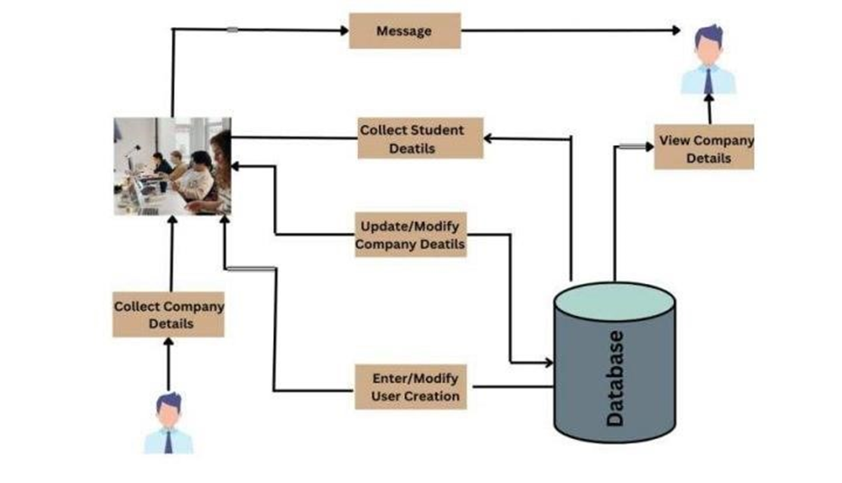

**Fig 4.1** **System Architecture**

Above figure explains the working of the proposed system. Next, The ICRPT Application represents the core software system. Users interact with the application through different modules, including the "Student Module," Admin Module, and HR Module.

The Core System Features encompass essential functionalities of ICRPT, including user profiles, job posting, assessments, comparison tools, notifications, data management, security, reporting, and analytics.

**Teacher(TPO) :** Teacher can create and manage students profiles. They can also post job related information. Teacher can communicate with students to provide guidance, feedback, or additional information regarding job placements. Access to analytics and reports related to student performance, job placement and the effectiveness of their recommendations.

**Student:** Students can create detailed profiles, including their education history, skills, achievements and career aspirations. Access to job listings posted by teachers or HR personnel. Students can apply for jobs, track application statuses. They can also receive updates on application statuses, interview invitations and other relevant information. Optional assessments or quizzes to evaluate and show their skills.

**HR:** HR personnel can create and manage company profiles including company information job listing and contact details & post job opening for students to apply. view and manage application from students including reviewing resume and profile. They can also communicate with students and teachers regarding job listing and selection processes. Provide feedback on the platform usability and the quality of candidates

The application design should ensure a seamless and efficient interaction between these modules to facilitate successful job placements.

* 1. **Entity-Relation Diagram (ER):**

The application can be displayed by means of graphical notation known as Entity Relationship diagram. The ER model describes data as entities, relationship and attributes. For a Training and Placement System, an ER diagram would represent the structure of the database or data model that stores information about students, companies, job placements, and related entities.

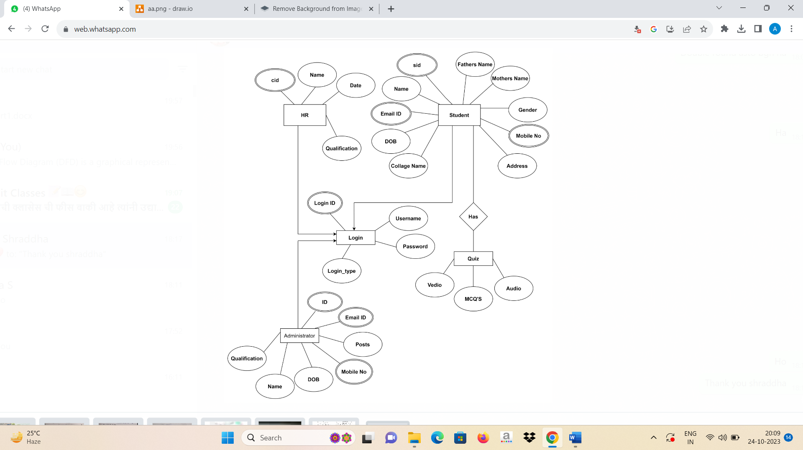

**Fig 4.2** **Entity-Relation Diagram (ER)**

**4.3 Data Flow Diagram**

A Data Flow Diagram (DFD) is a graphical representation of how data flows within a system. It's commonly used in software engineering and business analysis to model processes and data flow within an organization or a specific system. In the context of a Training and Placement System, the DFD diagram can illustrate how data moves within the system to manage the training and placement processes.

1. **DFD (Level-0)**

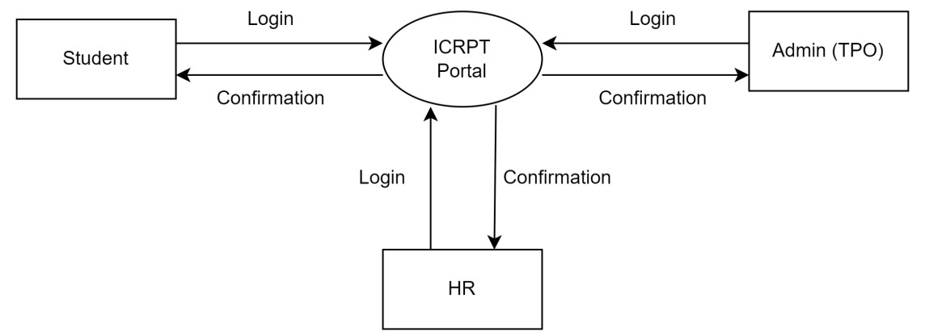

Fig.4.3.1 DFD Level 0

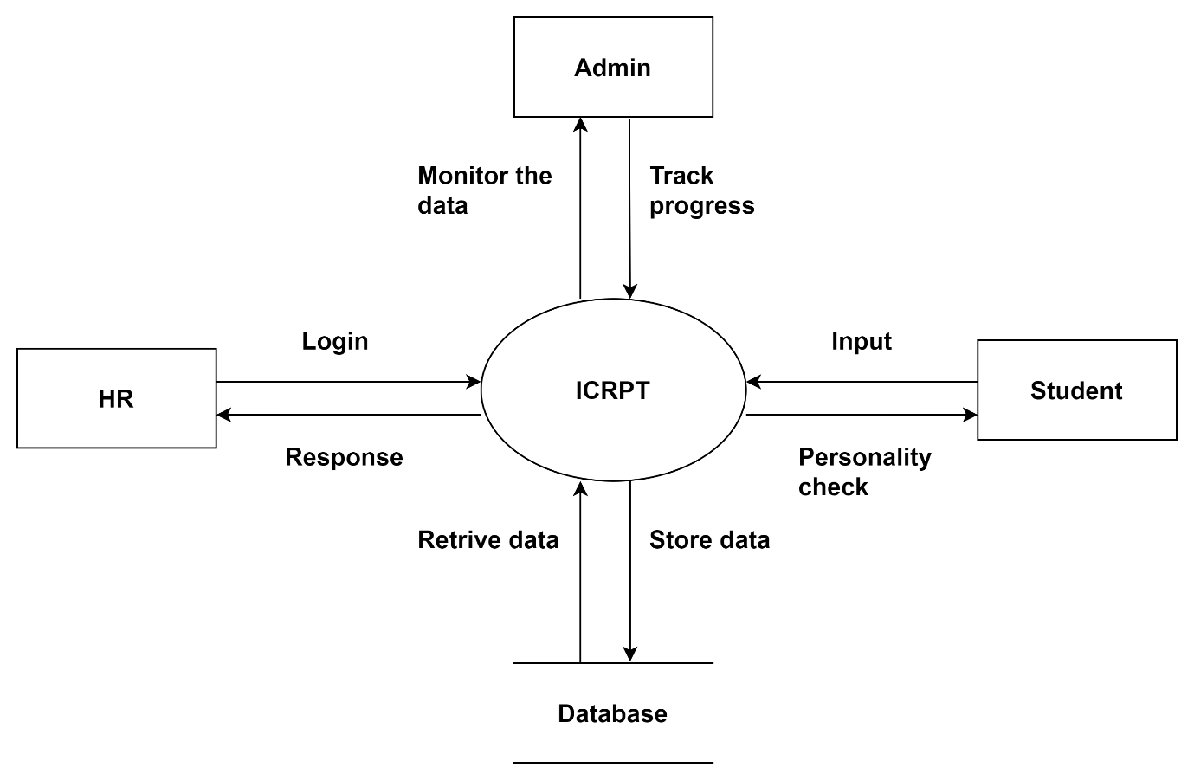

Fig.4.3.2 DFD Level-1

**ii. DFD (Level-1)**

1. **DFD (Level-2)**

* 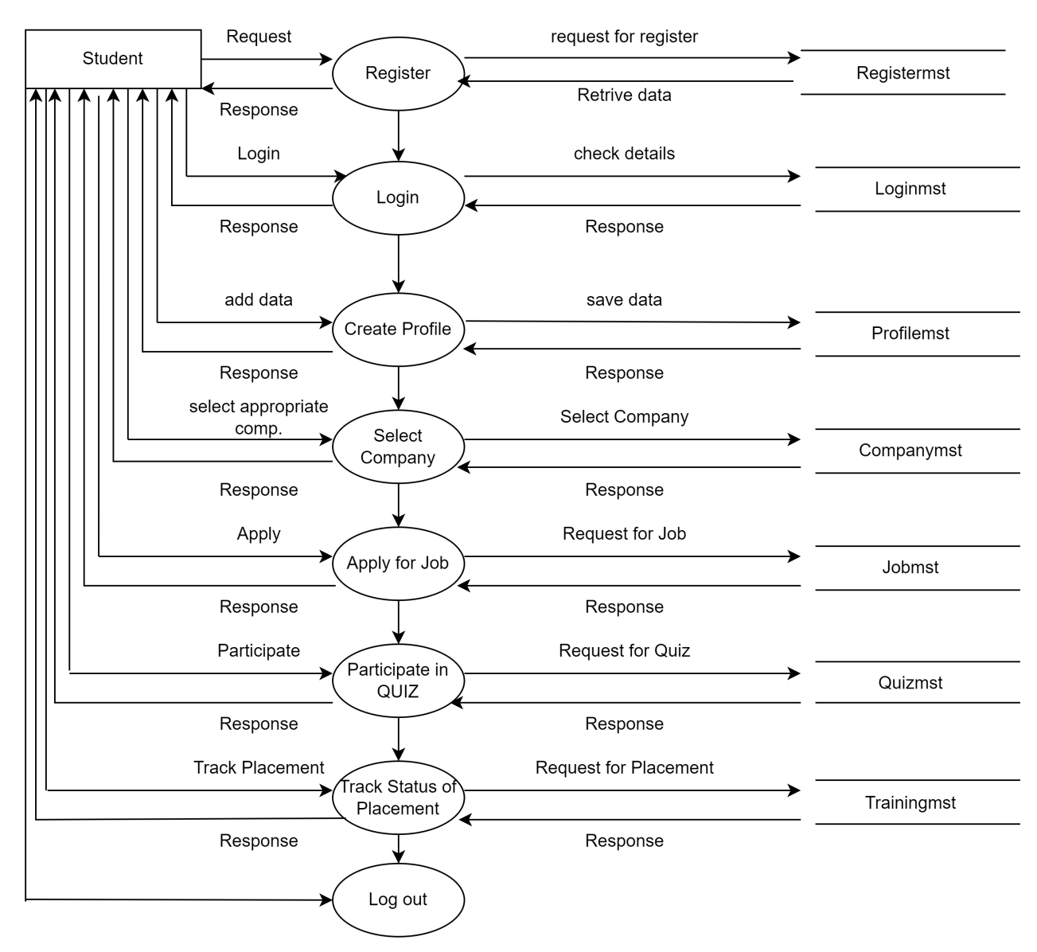**Student Module**

Fig 4.3.3 DFD Level-2 Student

* **Admin (TPO) Module:**

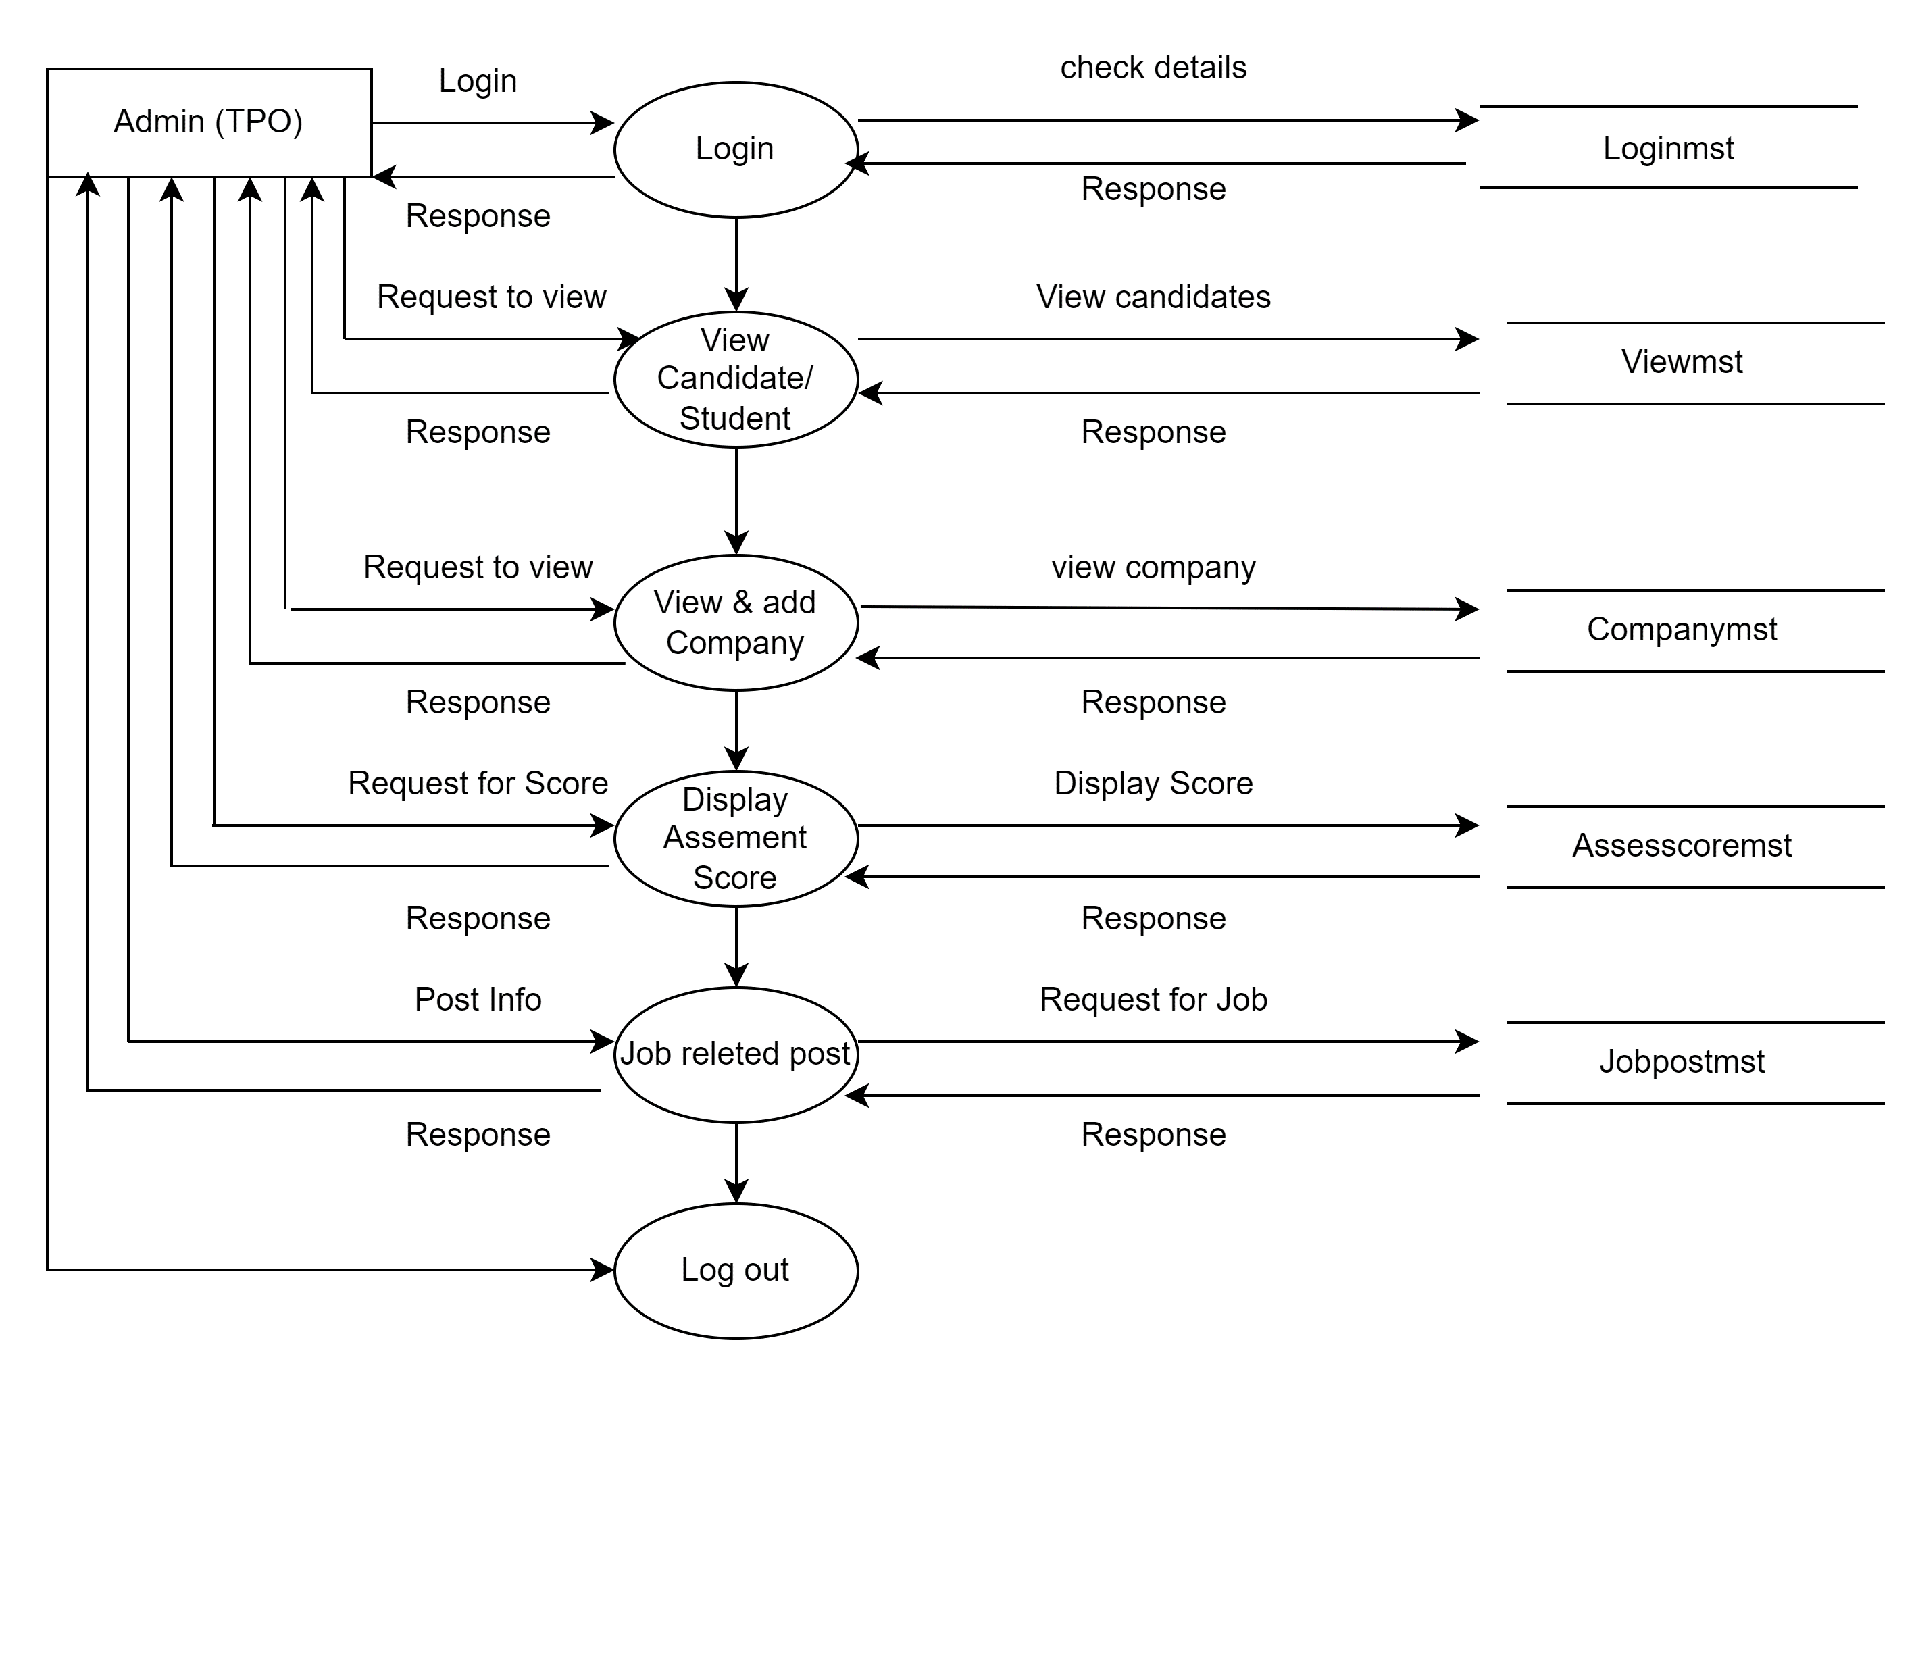

Fig 4.3.4 DFD Level-2 Admin (TPO)

* **HR Module:**

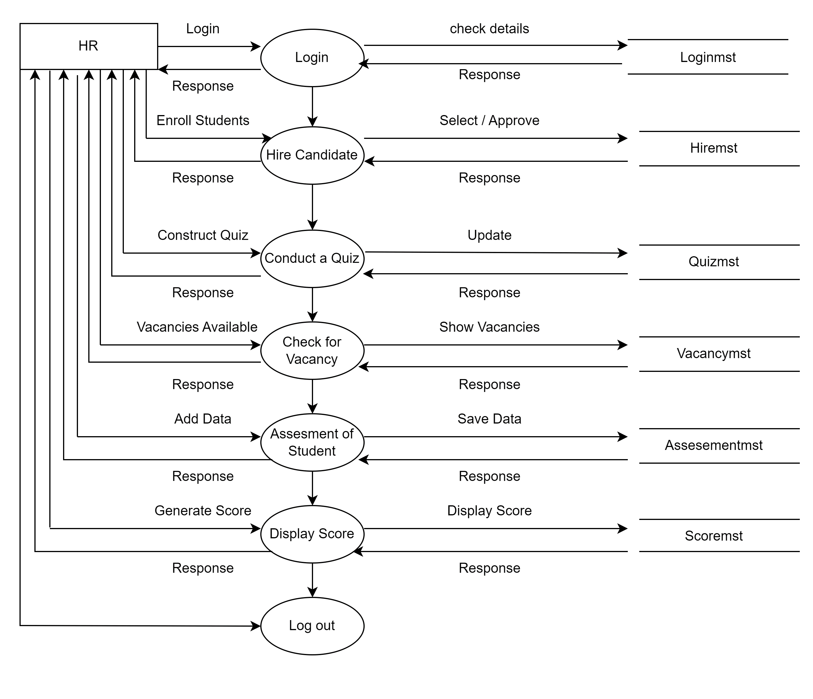

Fig 4.3.5 DFD Level-2 HR

* 1. **UML Diagrams:**

UML stands for Unified Modelling Language is a general purpose, developmental, modelling

language in the field of software engineering. That is intended to provide a standard to

visualize the design of the system. The accepted standard used when modelling assisting is

known as a UML. A generic set of notations that are used when creating Unified Modelling

Language diagrams. The Unified Modelling Language includes a set of graphic notation

technique to create visual models of object-oriented software’s.

* + 1. **Use Case Diagram:**

A use case diagram is a visual representation of the interactions and relationships between different actors and the system or application they use. In this case, we are creating a use case diagram for a student module that encompasses various functionalities such as registration, login, creating a profile, selecting a company, applying for a job, participating in a quiz, tracking placement status, receiving notifications, and logging out.

**Student:**

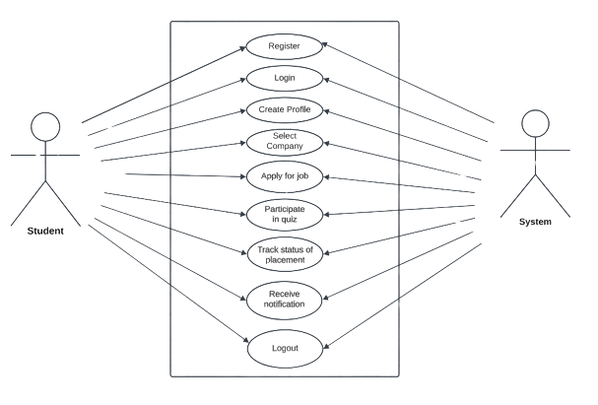

Fig. 4.4.1.1 Student

**Admin (TPO):**

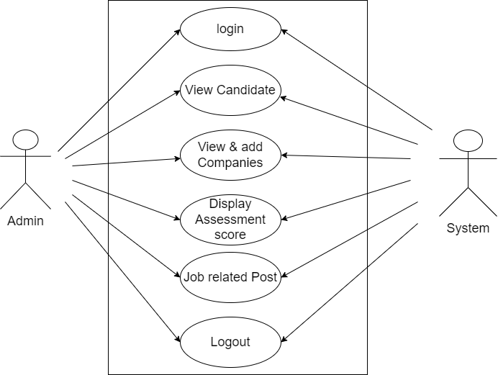

Fig. 4.4.1.2 Admin(TPO)

**HR:**

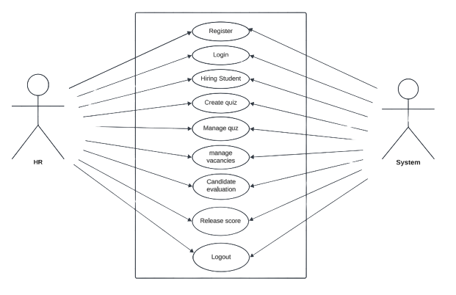

Fig. 4.4.1.3 HR

* + 1. **Class Diagram:**

Class Diagram is a static structure diagram that describes the structure of a system by showing

the system classes, their attributes, operations and relationships.

This system appears to be a comprehensive platform for managing various aspects of campus recruitment, including student and employer interactions, job postings, assessments, and administrative functions.

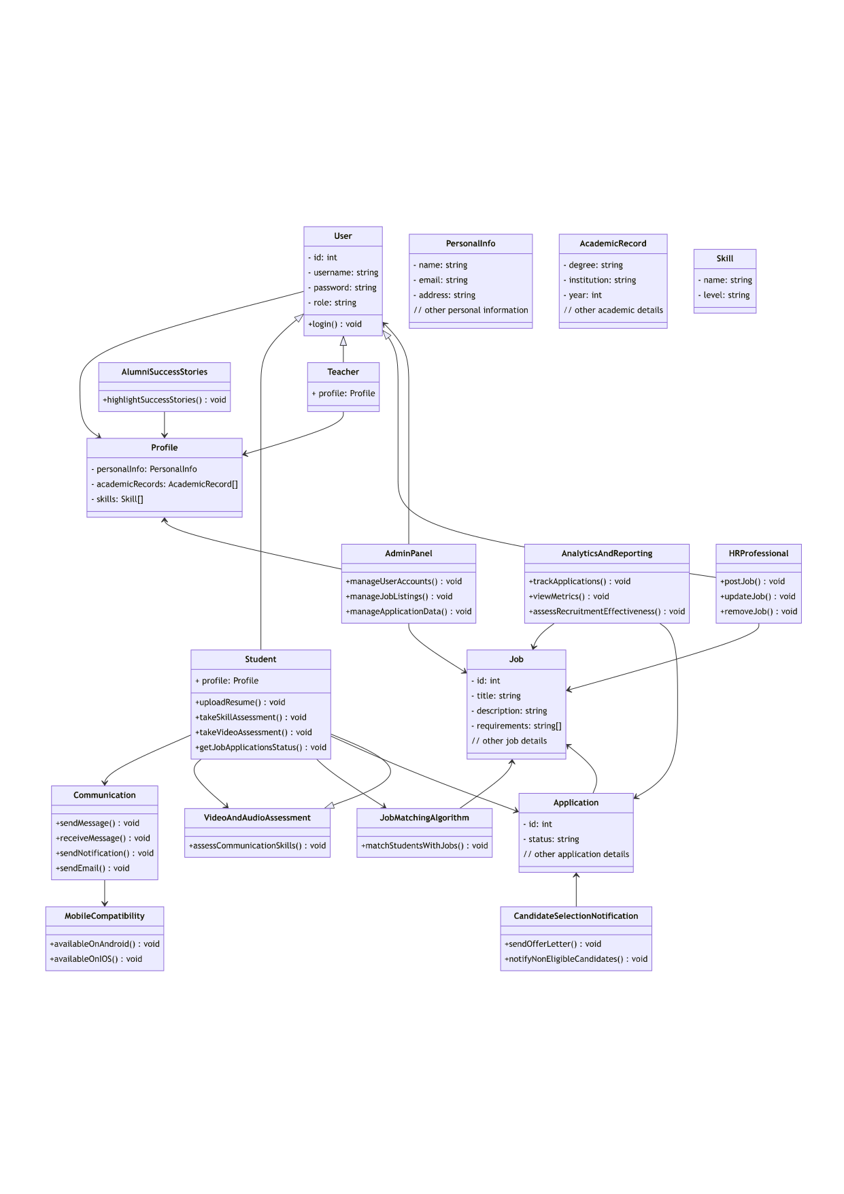

Fig.4.4.2 Class Diagram

**4.4.3 Activity Diagram:**

The Integrated Campus Recruitment, Placement, and Training Analysis (ICRPT) system comprises three modules: Student, HR, and Teacher. The Student Module allows students to log in securely, manage their profiles, communicate with HR professionals, and track job applications. The HR Module is for HR professionals, enabling them to post job vacancies, review applications, and send offer letters after secure login. The Teacher Module, designed for training and placement officers, facilitates job matching and analytics. All modules include validation processes, and valid logins grant access to respective functionalities, while invalid logins trigger error messages, with each module serving a specific role in campus recruitment and placement.

1. **Student Module**

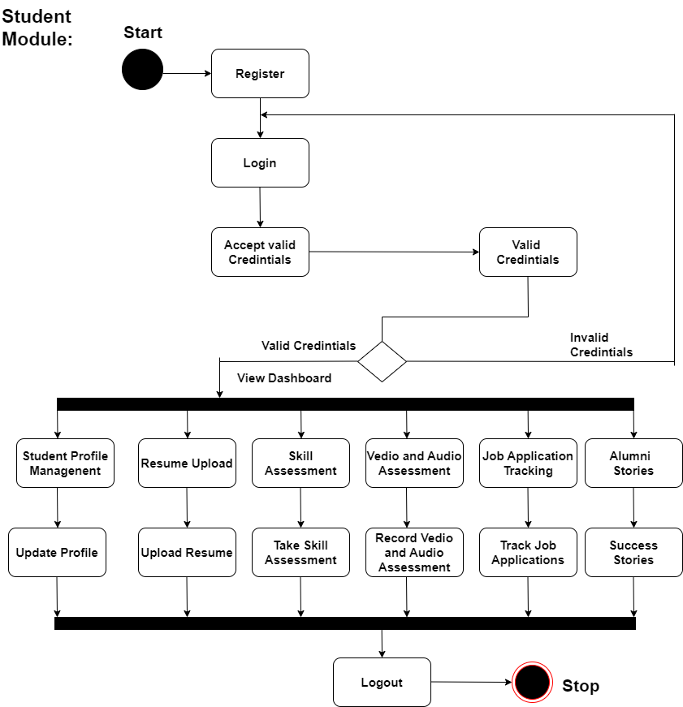

**Fig.4.4.3.1 Activity- Student**

1. **HR Module**

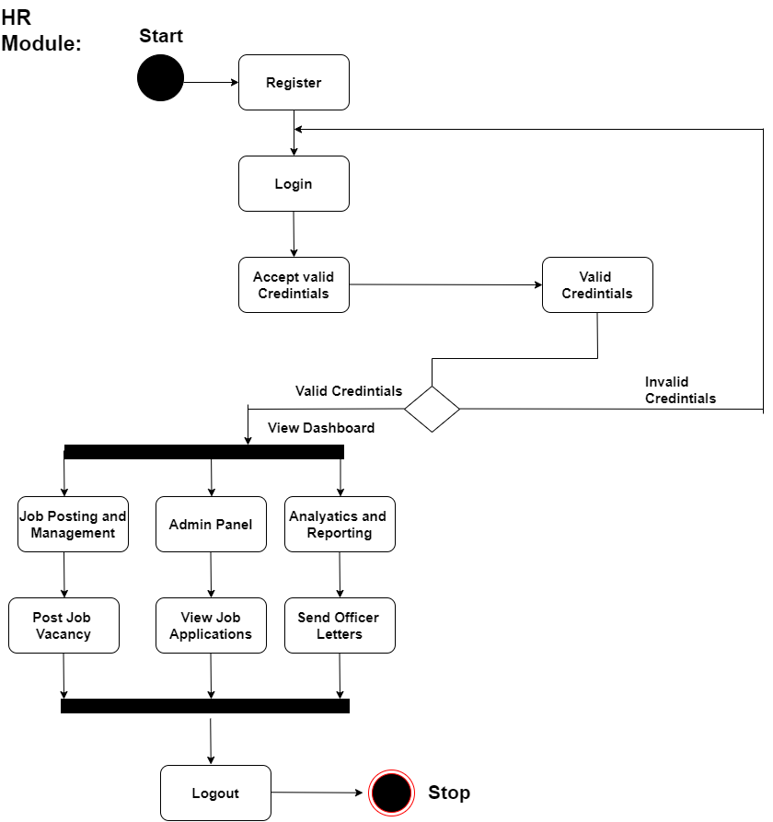

Fig.4.4.3.2 Activity- HR

1. **TPO Module:**

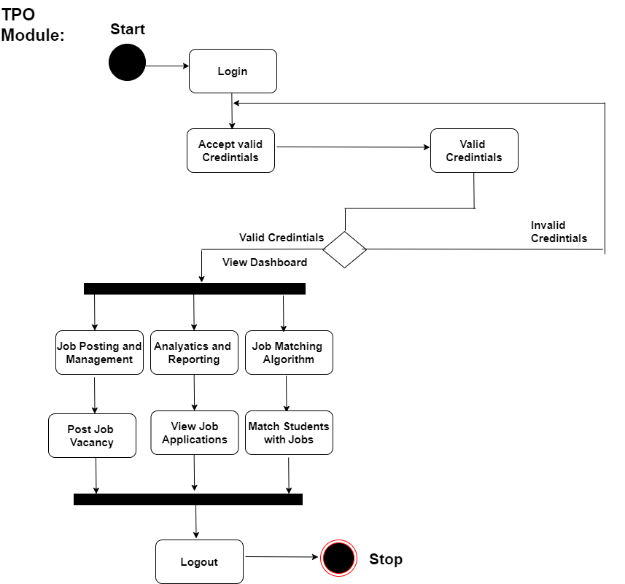

Fig.4.4.3.3 Activity- Admin(TPO)

**4.4.4 Deployment** **Diagram:**

The deployment diagram shows how the ICRPT system's components work together to provide a comprehensive solution for integrated campus recruitment, placement, and training analysis. It starts with users accessing the system through client devices, progresses through load balancing, web servers, and data processing on the application server. The system interacts with database servers, cloud services, and various other components to deliver a secure, reliable, and data-driven platform for both Students and Employers. The email server, security infrastructure, and integration with university systems add layers of functionality to meet the needs of all system stakeholders.

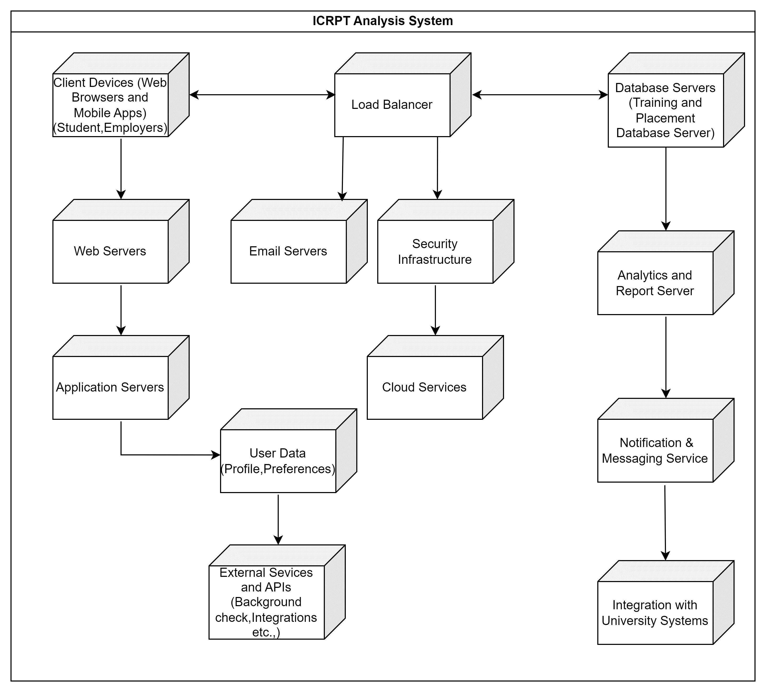

Fig.4.4.4 Deployment of ICRPT

**Chapter – 5 : FEATURES AND LIMITATIONS**

* **Features**

**1.** **User Authentication and Authorization:**

Secure login and user role management for students, teachers (TPO), and HR professionals.

**2. Student Profile Management:**

Creation and maintenance of comprehensive student profiles, including personal

information, academic records, and skills.

**3. Job Posting and Management:**

Posting, updating, and removal of job vacancies by HR professionals.

**4. Resume Upload:**

Students can upload their resumes making easy for employers to view their qualifications.

**5. Communication:**

send and receive functionality to facilitate communication between students and HR &

notification and email alerts to keep students informed about job opening.

**6. Admin panel:**

An administrative dashboard for managing users accounts, job listing and application data.

**7. Mobile compatibility:**

Ensure the application is available on both Android and iOS platform for wider

accessibility.

**8. Skill assessment:**

Users can take skill assessment tests or quizzes to showcase their expertise in specific area

to potential employers.

**9. Video and audio assessment:**

Students can show their communication skills and confidence through video and audio

assessment.

**10. Job Matching Algorithm**: Match students with jobs based on skills and preferences.

**11. Analytics and Reporting:** Track applications, view metrics, and assess recruitment

effectiveness.

**12. Job Application Tracking:** Enable students to track the status of their job applications,

including whether they are under review, shortlisted, or rejected.

**13. Alumni Success Stories:** Highlight success stories of alumni who have found employment

through the platform, inspiring current students and showcasing the system's effectiveness.

**14. Candidate Selection Notification:** Automatically send offer letters via email to eligible

candidates upon selection, and notify others if they are not eligible

* **Limitations**

**1. Limited job Opportunities:** The availability of job listing on these platform depends on

the companies and organizations using the service. Therefore, there might be a limited

number of job opportunities.

**2. Competition:** Due to the wide accessibility of these platforms, there can be intense

competition among students applying for the same job listings. This can make it

challenging for some students to secure placement.

**3. User Adoption:** Getting students, teachers, and HR professionals to actively use the system can be a challenge. It may take time for the user base to fully adopt the platform.

**4. Dependency on Internet Connectivity:** The system relies on internet access, which could be a limitation in areas with poor connectivity.

**Chapter – 6 : Applications & Result**

**6.1 – Applications**

1. **Education institutions:**

These application help educational institutions manage job placement services for their students, enhancing the employability of students.

1. **Corporate organizations:**

Companies can use these platform to streamline their hiring processes, contact with potential candidates and manage job posting and organization can advertise internship opportunities and select intern through these platform.

1. **Government initiatives:**

Government agencies can utilize training and placement application to provide job placement services and match job seekers with employers.

1. **Startups and small Businesses:**

Smaller companies may benefit from these platform as cost-effective solutions for finding and recruiting talent.

1. **Global employment**:

Some platforms have a global reach, connecting job seekers with opportunities worldwide facilitating international career development.

1. **Diversity and inclusion:**

Application can be tailored topromote diversity and inclusion by offering equal opportunities to candidate from various background.

**6.2 – Result/Achievements**

**Improved Placement Rates:**

Quantify the increase in the number of students who secured job placements as a result of using the ICRPT system. For example, you might mention a specific percentage increase.

**Improved Employer-Student Matching**:

Share statistics or case studies that demonstrate how the job matching algorithm led to better matches between employers and students.

**Increased Employer Satisfaction:**

Provide evidence of increased employer satisfaction through surveys, feedback, or more successful recruitments.

**Transparency:**

The placement process becomes more transparent, allowing students to track their progress and understand their employability.

**Competitive Advantage**:

Educational institutions using the ICRPT system gain a competitive edge by offering a more advanced and data-driven approach to training and placement.

**Long-Term Impact:**

The system contributes to the growth of an alumni network, strengthening relationships and support for educational institutions.

**Chapter – 7 : Conclusion**

In the rapidly evolving landscape of education and employment, Integrated campus recruitment, placement and training analysis (ICRPT) emerges as a transformative solution that bridges the gap between learning and professional opportunities. This dynamic system, designed to cater to educational institutions, organizations, and individuals alike, has the potential to reshape how we approach training, placement, and skill development. Throughout this discussion, we have explored the core concepts, advantages, design principles, and applications of ICRPT, shedding light on its far-reaching impact.

ICRPT play a pivot role in bridging the gap between job seekers and employers, facilitating career development and streamlining the recruitment process. They empower individuals to explore opportunities enhance their qualifications and connect with relevant job openings. These application have diverse applications across education, industry and workforce development, contributing to economic growth and fostering inclusivity in the job market. Their adaptability to changing workforce trends makes them essential tools in today’s dynamic employment landscape.

**Chapter – 8 : Future Scope**

**8.1 Scope of Project**

The scope of the ICRPT project encompasses the development of a comprehensive web and mobile application designed to facilitate the entire campus recruitment and placement process. It includes features such as user authentication, student and job profile management, job posting, communication tools, skill assessment, and data analytics. The system aims to streamline interactions between students, educational institutions, and HR professionals, enhancing career opportunities for students while providing data-driven insights for educational institutions and employers.

**8.2 Future Scope**

The Integrated Campus Recruitment, Placement, and Training (ICRPT) system holds significant potential for various sectors, and its future scope is quite promising. Here are several key areas of opportunity and development:

**1. Education Sector Enhancement:**

- The ICRPT system can further integrate with educational institutions, offering tailored curriculum recommendations based on industry demand and trends.

- Enhanced data analytics and predictive modeling can assist in optimizing training programs and improving student employability.

**2. Advanced AI and Machine Learning:**

- Implementing advanced AI and machine learning algorithms for better job matching, enabling more accurate skill assessment, and offering personalized learning paths.

- The application can analyze market trends, skill gaps, and emerging technologies, helping students make informed career choices.

**3. Global Expansion:**

- Expanding the system's reach to cater to international markets and facilitating global job placements.

- Incorporating multilingual support and cultural adaptability to serve a diverse range of users.

**4. Blockchain Integration for Credentials:**

- Utilizing blockchain technology for secure storage and verification of academic credentials, certificates, and skill assessments.

- Employers can trust the authenticity of applicants' qualifications.

**5. Enhanced Career Services:**

- Integrating additional career services, such as interview coaching, resume reviews, and mentorship programs.

- Providing a comprehensive career development ecosystem.

**6. Industry-Specific Modules:**

- Developing industry-specific modules for specialized sectors like IT, healthcare, finance, and engineering.

- Offering tailored features to meet the unique needs of each industry.

**7. Government and Non-profit Collaboration:**

- Partnering with government agencies and non-profit organizations to facilitate employment opportunities and vocational training for disadvantaged or underserved communities.

**8. AI-Driven Chatbots and Virtual Career Advisors:**

- Implementing AI-driven chatbots and virtual career advisors to provide immediate assistance to users, answering queries and offering guidance.

- Enhancing user experience and accessibility.

**9. Enhanced Security Measures:**

- Continuously evolving security features to protect sensitive user data, including biometric authentication and advanced encryption techniques.

- Ensuring data privacy and compliance with evolving data protection regulations.

**10. Data Analytics for Talent Acquisition:**

- Offering advanced analytics tools for HR professionals to identify and attract top talent effectively.

- Using big data analysis to optimize recruitment processes.

**11. Integration with Emerging Technologies:**

- Integrating with emerging technologies such as virtual reality (VR) and augmented reality (AR) for immersive training and assessment experiences.

- Utilizing blockchain for secure and transparent transactions, including contracts and payments.

**12. User-Friendly Mobile Apps:**

- Developing user-friendly mobile applications for both Android and iOS platforms, with an emphasis on responsive design and cross-platform compatibility.

- Facilitating on-the-go access and engagement.

**13. Sustainability and Corporate Social Responsibility (CSR):**

- Aligning the ICRPT system with sustainability initiatives and corporate social responsibility programs by promoting eco-friendly practices and diversity and inclusion.

The future scope of the ICRPT system is dynamic and adaptable, driven by technological advancements, user needs, and market dynamics. By continuously evolving and embracing emerging technologies, it can revolutionize the way students, educational institutions, and employers engage in recruitment, placement, and training.

**Chapter – 9 : REFERENCES**

*Book References:*

1. D. K. Arun, V. Namratha, B. V. Ramyashree, Y. P. Jain and A. Roy Choudhury, "Student Academic Performance Prediction using Educational Data Mining," 2021 International Conference on Computer Communication and Informatics (ICCCI), Coimbatore, India, 2021.

2. T. R. Kumar, T. Vamsidhar, B. Harika, T. M. Kumar and R. Nissy, "Students Performance Prediction Using Data Mining Techniques," 2019 International Conference on Intelligent Sustainable Systems (ICISS), Palladam, India.

3. E. N. Ogor, "Student Academic Performance Monitoring and Evaluation Using Data Mining Techniques," Electronics, Robotics and Automotive Mechanics Conference (CERMA 2007), Cuernavaca, Mexico.

4. Fahim, A.M., Salem, A.M., Torkey, F.A. et al. An efficient enhanced k-means clustering algorithm. J. Zhejiang Univ.

5. Python Machine Learning by Sebastian Raschka and Valid Mirjalili.

6. Deep learning by Lan Goodfellow, Yoshua Bengio and Aaron Courville.

7. Interaction Design: Beyond human-computer interaction by Jenny Preece, Yvonne Rogers and Helen Sharp.

8. Raji, M., Duggan, J., DeCotes, B., Huang, J., & Zanden, B. V. (2017). Visual Progression Analysis of Student Records Data. 2017 IEEE Visualization in Data Science (VDS), 2–5. https://doi.org/10.1109/vds.2017.8573447

*Bibliography:*

• https://www.iitms.co.in/higher-education-erp/training-and-placement/

• https://www.ijert.org/online-training-and-placement-management-system

• https://www.ijsdr.org/papers/IJSDR2004064.pdf